MINI PROJECT ON ‘BANK MANAGEMENT SYSTEM’

Submitted in the partial fulfilment of the requirements for
the award of degree of
BACHELOR IN COMPUTER APPLICATIONS (BCA)
To
DEPARTMENT OF COMPUTER APPLICATIONS
UTTARANCHAL SCHOOL OF COMPUTING SCIENCES



Under the Supervision of Submitted by
Dr. Manoj Aswal Anubhav Gahlout
Assistant Professor 2509000096
BCA – E II Sem

ACKNOWLEDGEMENT

First and foremost, I would also like to thank my parents for giving me the opportunity to pursue my education at Uttaranchal University in Dehradun. I would like to express my sincere gratitude to our respected Dean, Prof. Dr. Sonal Sharma, and Head of Department, Prof. Dr. Sameer Dev Sharma, for their continuous support, guidance, and encouragement throughout the completion of this project. I would also like to convey my heartfelt appreciation to our Project Mentor, Dr. Manoj Aswal, for his invaluable assistance in preparing the project and compiling the project materials. I am grateful for his consistent guidance and for providing the necessary facilities for our computer project file.
Most importantly, I would like to thank everyone who helped me complete my project, whether directly or indirectly.

Anubhav Gahlout
BCA-E 2nd Sem

DECLARATION

I hereby declare that this project work entitled “Bank Management System” submitted by Anubhav Gahlout to Uttaranchal Institute of Computing sciences. It is an authentic record of my work carried out at “UTTARANCHAL UNIVERSITY” under the guidance of
Dr. Manoj Aswal.

CERTIFICATE OF ORIGINALITY

This is to certify that the project entitled “Bank Management System” by Anubhav Gahlout has been submitted in the partial fulfilment of the requirements for the award of the degree of BCA-II from Uttaranchal University, Dehradun. The results embodied in this project have not been submitted to any other University or Institution for the record of any degree.

Under the guidance of:
Dr. Manoj Aswal

TABLE OF CONTENTS
ACKNOWLEDGEMENT………………………………………………………………...……I
DECLARATION……….………………………………………………………………………II
CERTIFICATE OF ORIGINALITY…………………………………………...…………...... III
LIST OF TABLES
- INTRODUCTION…………………………………………………….……………….…...1
- OBJECTIVE…………………………………………………………………………..........2
- SYSTEM ANALYSIS…………...…………………………………………….…............3-6
    - IDENTIFICATION OF NEED
    - PRELIMINARY INVESTIGATION
    - FEASIBILITY STUDY
    - PROJECT PLANNING
    - SYSTEM REQUIREMENT SPECIFICATIONS(SRS)
    - MINIMUM SYSTEM REQUIREMENTS:
    - PROJECT PLANNING
    - SOFTWARE ENGINEERING PARADIGM

- PROJECT SCHEDULING ……………………………….…………………………….7-8
    - GANTT CHART
    - PERT CHART

- DATA MODEL ………………………………………....….…………………...………8-11
5.1 DATA FLOW DIAGRAM (DFD)
    - LEVEL-0 DFD
    - LEVEL-1 DFD
    - LEVEL-2 DFD
  - ER DIAGRAMS
  - CLASS DIAGRAMS

- SYSTEM DESIGN……………….……………………………………………….…......12
6.1. MODULARISATION DETAILS
6.2. USER INTERFACE DESIGN

- TESTING…………………………………………...………………………………….…13
- SYSTEM SECURITY MEASURES…………………………………….…………….…14
- CODE………………………………………………………………………………….15-23
9. OUTPUT……………………………………………….…………………………....….24-25
11. FUTURE SCOPE…………………………………………………………………….…....26
12.BIBLIOGRAPHY………………………………………………………………….……....27

INTRODUCTION

A Bank Management System (BMS) is a software application designed to manage and automate the day-to-day operations of a bank. It helps in maintaining customer accounts, processing financial transactions, storing account information, and providing efficient banking services.
In traditional banking systems, many processes such as account management, deposit and withdrawal transactions, and record maintenance were handled manually. These manual processes were time-consuming and often resulted in errors and inefficiencies. As banking operations expanded and the number of customers increased, managing records manually became difficult.
The Bank Management System provides a computerized solution to these problems. It allows bank staff to manage customer accounts, perform transactions, and access account information quickly and accurately. The system helps in maintaining a database of customers, their accounts.
.
The Bank Management System simplifies banking operations, improves efficiency, reduces manual errors, and ensures proper management of financial records. By automating banking activities, the system helps banks provide faster and more reliable services to their customers.

2. OBJECTIVE

The main objective of the Bank Management System is to develop a computerized application that helps manage banking operations efficiently. The system aims to reduce manual work, improve accuracy, and ensure secure handling of financial information.
The objectives of this project are as follows:
- Efficient Account Management
To maintain detailed records of bank customers and their accounts in an organized digital format.
- Fast Transaction Processing
To enable quick deposit and withdrawal operations without manual calculation errors.
- Secure Data Storage
To store customer information and transaction details securely using file handling techniques.
- Easy Access to Information
To allow bank staff to easily search and retrieve account information when required.
- Reduce Paperwork
To minimize the use of physical registers and paperwork in banking operations.
- Improve Service Quality
To provide faster and more reliable banking services to customers.

SYSTEM ANALYSIS
    - IDENTIFICATION OF NEED
In many small banking systems, records are maintained manually, which is time-consuming and prone to errors. There is a need for a computerized system that can manage customer accounts efficiently. The Bank Management System helps in reducing manual work, improving accuracy, and providing quick access to account information.

PRELIMINARY INVESTIGATION
The existing system is mostly manual and involves maintaining records in registers or basic files. This leads to issues such as data redundancy, calculation errors, and difficulty in searching account details. After analyzing the current system, it was found that a simple computerized solution can improve efficiency and reduce errors.

FEASIBILITY STUDY
The proposed system is feasible in the following ways:
Technical Feasibility: The system is developed using C++ and file handling, which are easy to implement and do not require advanced technology.
Economic Feasibility: The system does not require expensive hardware or software, making it cost-effective.
Operational Feasibility: The system is simple to use and can be easily operated by users with basic computer knowledge.

]

PROJECT PLANNING
Project planning is an important step in software development. It involves identifying all the tasks required to complete the project and organizing them in a proper sequence.
The development of the Bank Management System was planned in the following phases:
- Requirement analysis in this phase, the problem was studied and the requirements of the system were identified. The need for a computerized banking system was analyzed.
- System design in this phase, the structure of the system was designed. Different modules such as account creation, transaction processing, and account display were planned.
- Implementation (Coding) in this phase, the actual program was developed using C++ language. All functionalities such as create account, deposit, withdraw, and balance check were implemented.
- File Handling Implementation file handling was used to store and retrieve account data permanently. Data was written and read from a file named “accounts.txt”.
- Testing and debugging the system was tested with different inputs to ensure correct functionality. Errors were identified and corrected during this phase.
- Documentation in this phase, the complete project report was prepared, including diagrams, charts, and explanations.

SYSTEM REQUIREMENT SPECIFICATIONS(SRS)
Functional Requirements
The system should perform the following functions:
- Create new bank accounts with user details
- Deposit money into an account
- Withdraw money from an account
- Check account balance
- Search for an existing account
- Display all account details
- Delete an account
- Store and retrieve data using file handling

Non-Functional Requirements
The system should satisfy the following conditions:
- The system should be simple and user-friendly
- The system should provide accurate results
- The system should respond quickly to user inputs
- The system should store data permanently using files
- The system should handle invalid inputs properly

Constraints
- The system is console-based (no graphical interface)
- The system is developed using C++ language
- Data is stored in a file instead of a database
- Limited number of accounts can be stored (array size fixed)

    - MINIMUM SYSTEM REQUIREMENTS:
- Processor: Intel Core i3 or higher
- RAM: 4 GB or above
- Hard Disk: At least 1 GB free space
- Operating System: Windows
- Input Devices: Keyboard
- Device: Monitor

3.1.8. SOFTWARE ENGINEERING PARADIGM
Heading: Software Engineering Paradigm
The development of this project follows the Waterfall Model. In this model, the development process is divided into different phases, and each phase is completed before moving to the next phase.
The phases include:
Requirement Analysis – Understanding the problem and system requirements
System Design – Designing the structure and modules
Implementation – Writing the program code
Testing – Checking for errors and fixing them
Documentation – Preparing the final project report

3.1.7 PROJECT PLANNING
Project planning is an essential stage in software development. It involves identifying the tasks required to complete the project and organizing them in a systematic manner.
The development of the Bank Management System includes the following phases:
- Requirement Analysis
- System Design
- Implementation (Coding)
- Testing
- Documentation

- PROJECT SCHEDULING

4.1.1 GANTT CHART

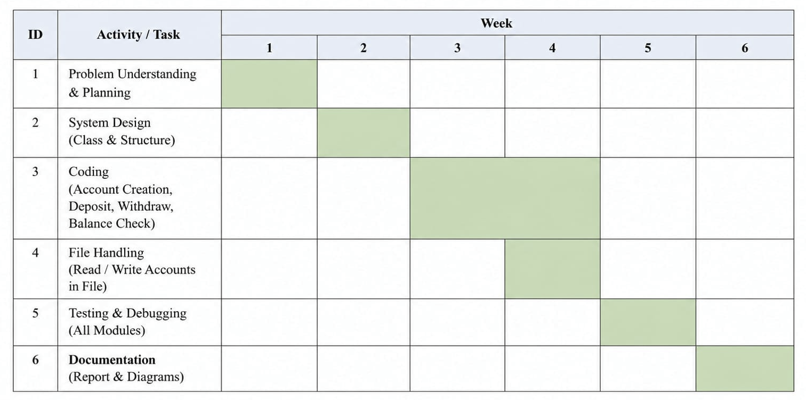

4.1.2 PERT CHART

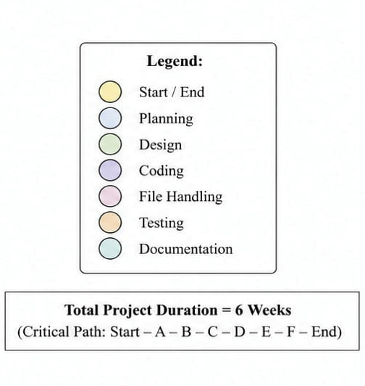
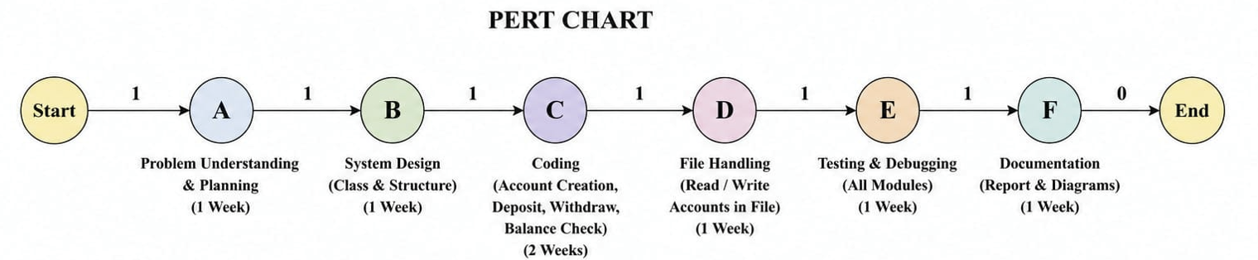

5.DATA MODEL

DATA FLOW DIAGRAM (DFD)

5.1.1 Level-0 DFD

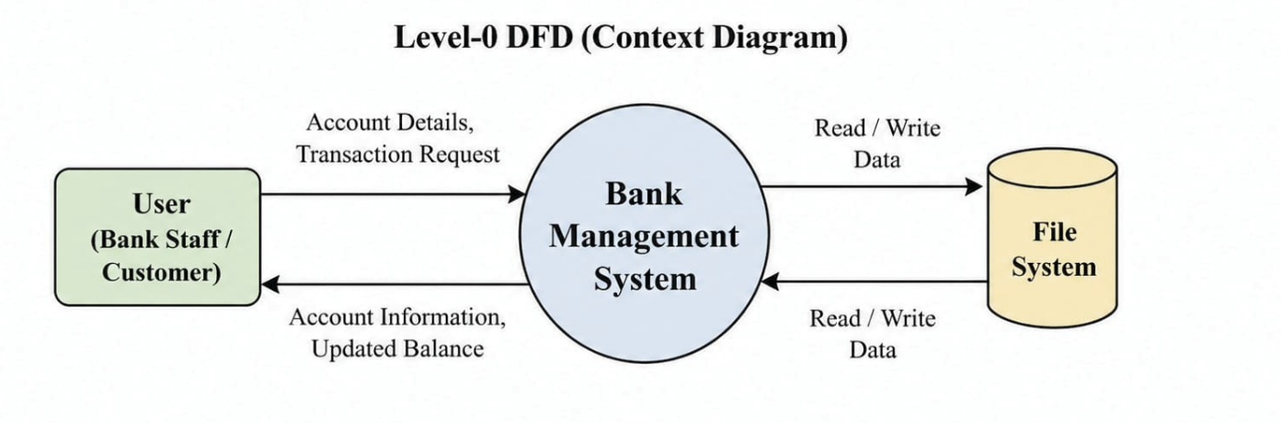

Level-1 DFD
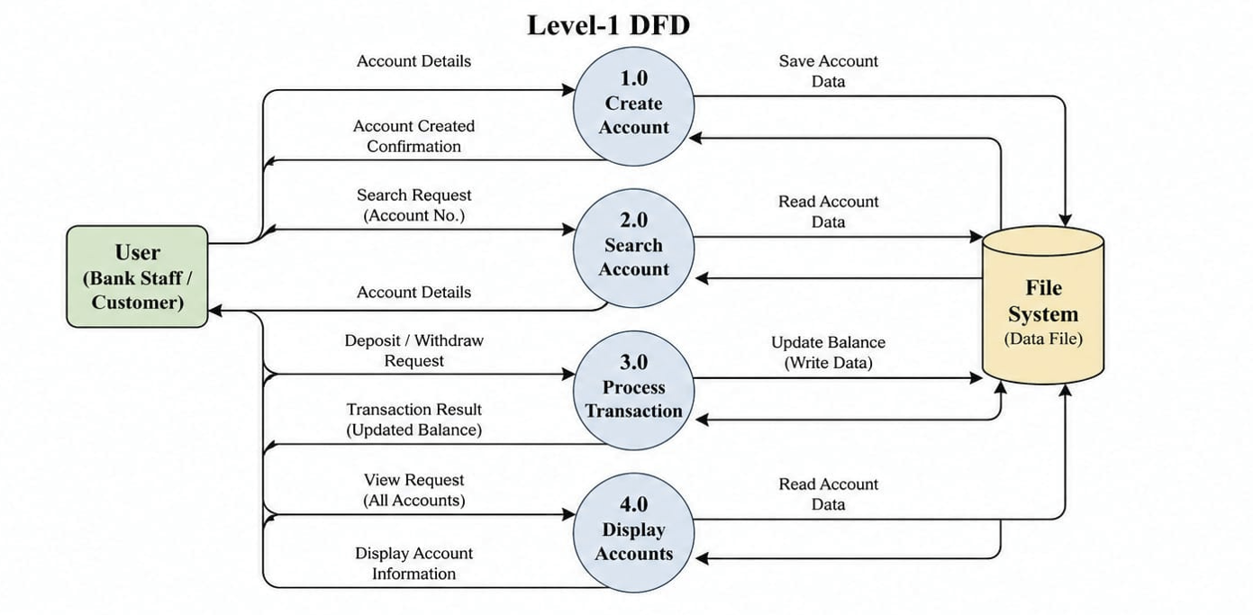

Level-2 DFD

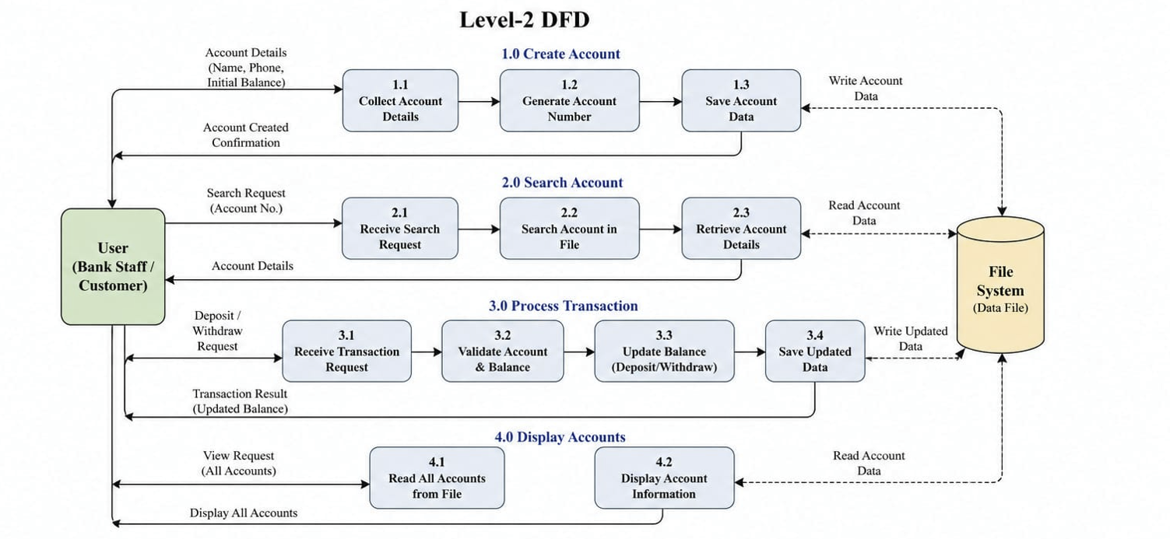

5.2 ER DIAGRAM

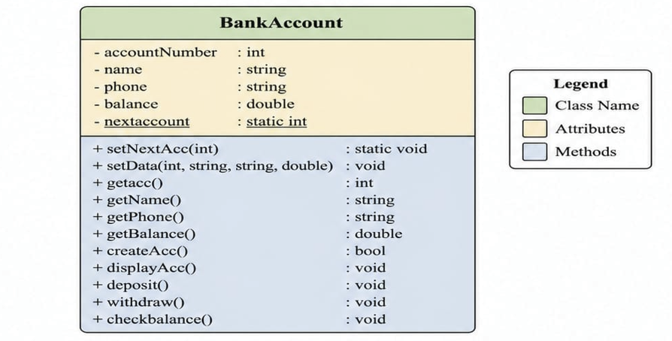
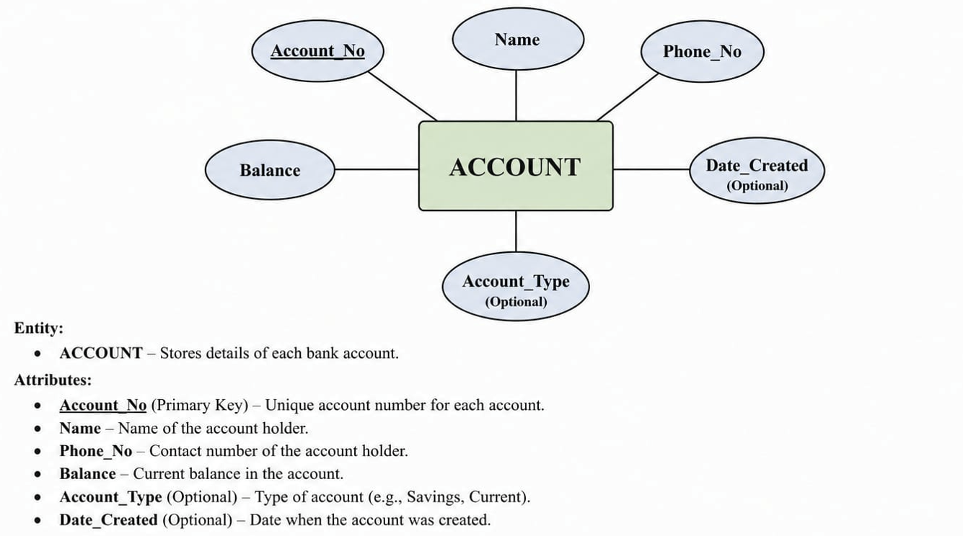
5.3 CLASS DIAGRAM

6.SYSTEM DESIGN
6.1 MODULARISATION DETAILS:
The system is divided into different modules to make it simple and easy to manage.
- Account Creation Module
Used to create a new account by taking user details and storing them in a file.
- Transaction Module
Handles deposit and withdrawal operations and updates the account balance.
- Account Search Module
Used to find an account using account number.
- Account Display Module
Displays account details and balance.
- Account Deletion Module
Used to delete an existing account from the system.

6.2 USER INTERFACE DESIGN
The system uses a simple console-based interface. Users interact with the system through a menu where different options are displayed. The user selects an option and enters the required details. The interface is easy to use and does not require advanced technical knowledge.

7. TESTING
The system was tested using different inputs to ensure proper working of all functionalities. Testing was performed to check the accuracy and reliability of the system.
The following test cases were used:
- Creating accounts with valid and invalid data
- Deposit operation with valid amount
- Withdrawal operation with sufficient and insufficient balance
- Searching for existing and non-existing accounts
- Checking balance functionality
All modules were tested successfully, and errors were identified and corrected during the debugging process.

8. SYSTEM SECURITY MEASURES

The system uses basic security measures to ensure correct data handling.
Input validation is applied to avoid invalid entries such as negative amounts.
The system maintains a minimum balance condition during withdrawal.
Data is stored in a file which helps in preserving information even after program termination.
These measures help in maintaining data accuracy and basic security of the system.

9. CODE:

#include <iostream>
#include <stdlib.h>
#include <string>
#include <fstream>
using namespace std;

class bankAccount
{

int accountNumber;
static int nextaccount;
string name;
double balance;
string phone;

public:
static void setNextAcc(int val)
{
nextaccount = val;
}
void setData(int accNo, string nam, string ph, double bal)
{
accountNumber = accNo;
name = nam;
phone = ph;
balance = bal;
}
int getacc()
{
return accountNumber;
}

bool createAcc();
void displayAcc();
void deposit();
void withdraw();
void checkbalance();

string getName()
{
return name;
}
string getPhone()
{
return phone;
}
double getBalance()
{
return balance;
}
};

int bankAccount::nextaccount = 1000;

bool bankAccount::createAcc()
{
cout << "Enter Name: ";
cin.ignore();
getline(cin, name);

cout << "Enter Phone Number: ";
cin >> phone;

cout << "Enter Initial Balance: ";
cin >> balance;

if (balance < 500)
{
cout << "Mininimum balance is 500\n";
return false;
}
else
{
accountNumber = nextaccount++;
ofstream file("accounts.txt", ios::app);
file << accountNumber << " "
<< name << " "
<< phone << " "
<< balance << endl;

file.close();
cout << "Accounts Create Successfully" << endl;
cout << "Your Account Number is: " << accountNumber << endl;
}

return true;
}

void bankAccount::displayAcc()
{
cout << "Name of Account Holder: " << name << endl;
cout << "Account Number: " << accountNumber << endl;
cout << "Phone Number: " << phone << endl;
cout << "Balance: " << balance << endl;
}

void bankAccount::deposit()
{
double amount;
cout << "Enter amount: ";
cin >> amount;
if (amount <= 0)
{
cout << "Amount is not valid";
return;
}
else
{
balance = balance + amount;
cout << "Amount Successfully Deposit";
}
}

void bankAccount::withdraw()
{
double amount;
cout << "Enter Amount: ";
cin >> amount;
int minibal = 500;

if (amount <= 0)
{
cout << "Invalid Amount";
return;
}

if (amount > balance)
{
cout << "Insufficient balance";
return;
}
else if (balance - amount >= minibal)
{
balance = balance - amount;
cout << "withdraw successful";
}
else
{
cout << "Cannot withdraw, minimum balance must remain 500";
}
}

void saveAllAccounts(bankAccount acc[], int count)
{
ofstream file("accounts.txt");

for (int i = 0; i < count; i++)
{
file << acc[i].getacc() << " "
<< acc[i].getName() << " "
<< acc[i].getPhone() << " "
<< acc[i].getBalance() << endl;
}

file.close();
}

void bankAccount::checkbalance()
{
cout << "Balance is: " << balance << endl;
}

int main()
{
bankAccount acc[500];
int choose;
int count = 0;
int max = 0;

ifstream file("accounts.txt");
int accNo;
string name, phone;
double balance;

while (file >> accNo >> name >> phone >> balance)
{
acc[count].setData(accNo, name, phone, balance);
count++;
if (accNo > max)
{
max = accNo;
}
}

bankAccount::setNextAcc(max + 1);
file.close();
do
{
cout << "1.Create Account" << endl;
cout << "2.Search Account " << endl;
cout << "3.Deposit Money" << endl;
cout << "4.withdraw Money" << endl;
cout << "5.Check Balance" << endl;
cout << "6.Show all accounts" << endl;
cout << "7.Delete Account" << endl;
cout << "8.Exit" << endl;
cout << "Enter choice: ";
cin >> choose;

switch (choose)
{
case 1:

if (acc[count].createAcc())
{
count++;
}

break;
case 2:
{
int accNum;
cout << "Enter Account Number: ";
cin >> accNum;
bool found = false;
for (int i = 0; i < count; i++)
{
if (acc[i].getacc() == accNum)
{
acc[i].displayAcc();
found = true;
break;
}
}
if (found == false)
{
cout << "Account not Found" << endl;
}
break;
}

case 3:
{
int accNo;
cout << "Enter Account Number: ";
cin >> accNo;
bool found = false;

for (int i = 0; i < count; i++)
{
if (acc[i].getacc() == accNo)
{
acc[i].deposit();
saveAllAccounts(acc, count);
found = true;
break;
}
}
if (found == false)
{
cout << "Account Not found";
}
break;
}

case 4:
{
int accNum;
cout << "Enter Account Number: ";
cin >> accNum;
bool found = false;

for (int i = 0; i < count; i++)
{
if (accNum == acc[i].getacc())
{
acc[i].withdraw();
saveAllAccounts(acc, count);
found = true;
break;
}
}
if (found == false)
{
cout << "Account Not found";
}

break;
}

case 5:
{
int AccNo;
cout << "Enter Account Number: ";
cin >> AccNo;
bool found = false;
for (int i = 0; i < count; i++)
{
if (AccNo == acc[i].getacc())
{
acc[i].checkbalance();
found = true;
break;
}
}
if (found == false)
{
cout << "Acount not found";
}
break;
}

case 6:
if (count == 0)
{
cout << "Accounts not exist" << endl;
}
else
{
for (int i = 0; i < count; i++)
{
acc[i].displayAcc();
}
}
break;

case 7:
{
int accNo;
cout << "Enter Account Number: ";
cin >> accNo;
bool found = false;
int index = 0;
for (int i = 0; i < count; i++)
{
if (accNo == acc[i].getacc())
{
index = i;
found = true;
break;
}
}

if (found == true)
{
for (int i = index; i < count - 1; i++)
{
acc[i] = acc[i + 1];
}
count--;
saveAllAccounts(acc, count);
}
else
{
cout << "Account not found\n";
}
break;
}
case 8:
cout << "Exiting....." << endl;
exit(0);
break;
default:
cout << "Invalid Choice";
break;
}

} while (1);

return 0;
}

10. OUTPUT:

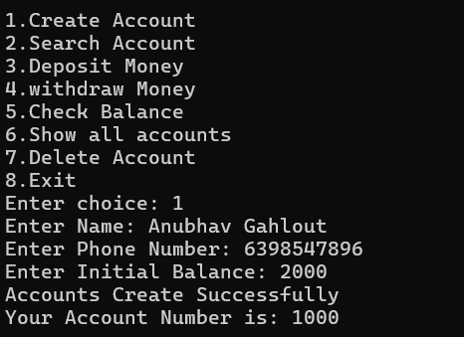
Create Account

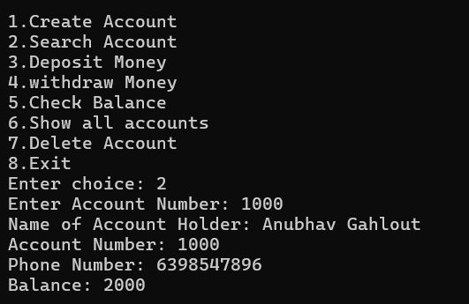
Search Account

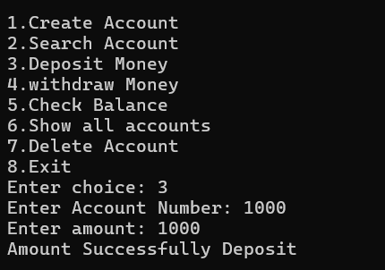
Deposit Money
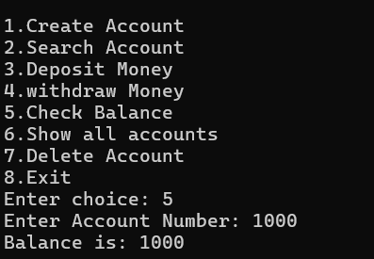
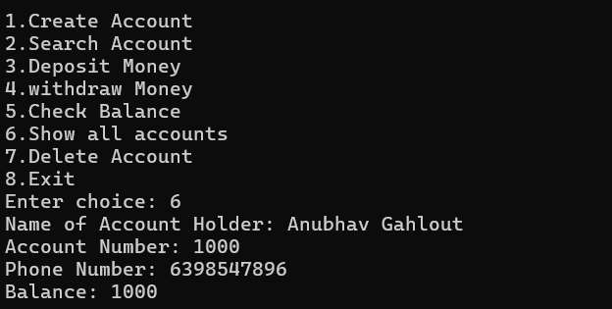
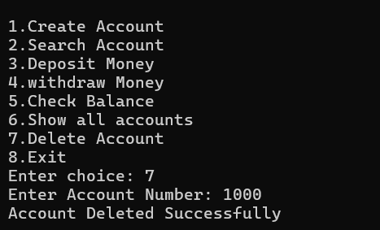
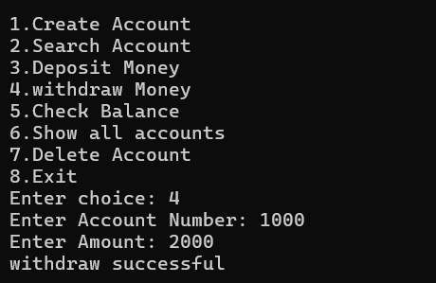
Delete Account
Show All Accounts
Check Balance
Withdraw Money

11. FUTURE SCOPE

The Bank Management System can be improved in the future by adding advanced features.
Some possible enhancements are:
- Graphical User Interface (GUI) for better user experience
- Login system for security
- Database integration instead of file handling
- Online banking features
- SMS or email notifications
- Mobile application support
These improvements can make the system more efficient and suitable for real-world applications.
.

12. BIBLIOGRAPHY

The following resources were used for the preparation of this project:
- https://www.geeksforgeeks.org
- https://www.includehelp.com
- https://www.tutorialspoint.com
- https://www.w3schools.com

